EXPERIMENT NO:5
AIM: Configure a network and Implement Static Routing.
TOOLS/SOFTWARES REQUIRED: Cisco Packet tracer
THEORY:
A computer network is formed by connecting multiple devices such as computers, switches, and routers to enable communication and data transfer between them. When devices are present in different networks or subnets, routers are used to forward data packets from one network to another. For this purpose, routers maintain a routing table that contains information about different network paths.
Static routing is a routing technique in which routes are manually added to the routing table of a router. These routes define the destination network and the path through which packets should be forwarded. Unlike dynamic routing, static routing does not use routing protocols to automatically learn or update routes. The routing information remains fixed unless it is modified by the network administrator.
In a network configured with static routing, each router must have correct routing information to ensure successful communication between different networks. Static routing provides a simple and controlled method of packet forwarding and helps in understanding how routers select paths for data transmission. It is commonly used in small networks and educational environments where the network topology is simple and changes are infrequent.
Implementing static routing in a simulated network environment helps in understanding the basic concepts of inter-network communication, routing tables, and packet forwarding. It provides practical insight into how routers manage network paths and how data is transmitted between multiple networks.

OUTPUT:
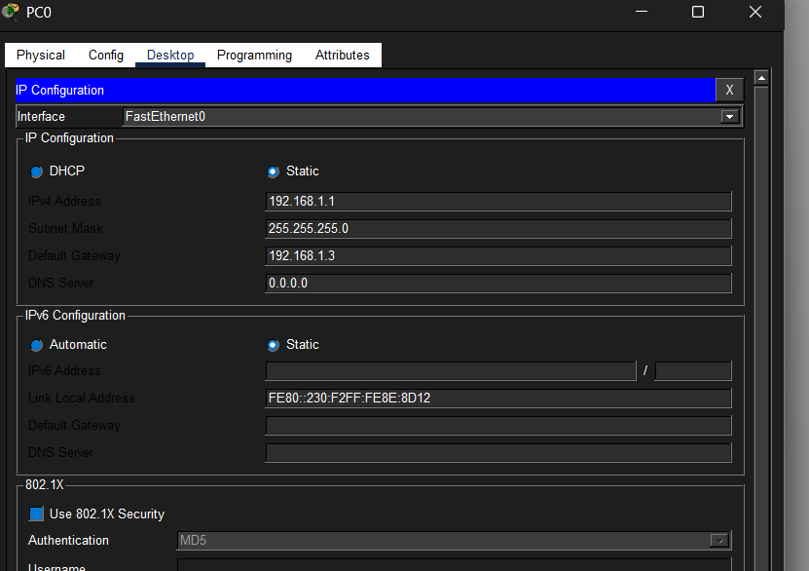
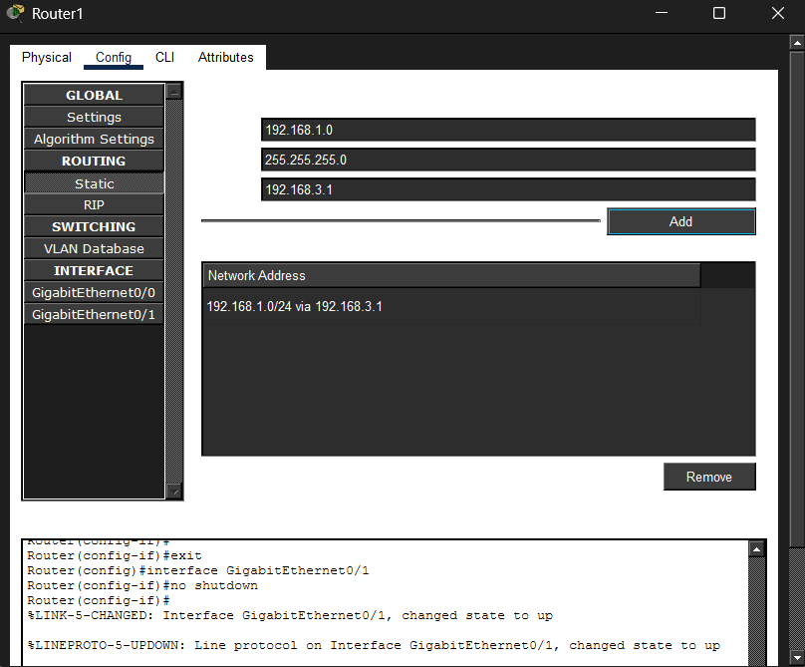
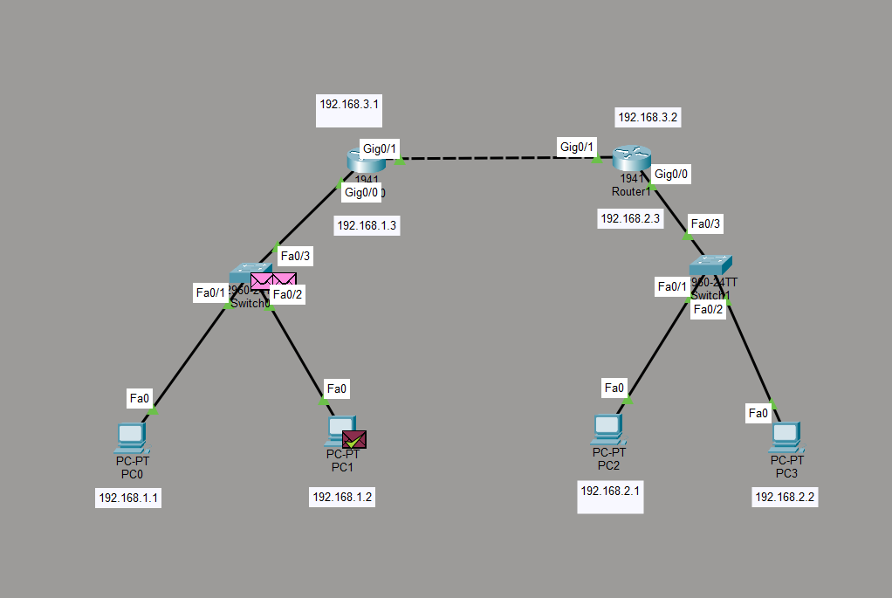
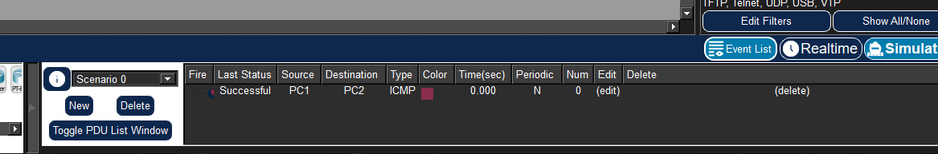
CONCLUSION:
This experiment helped me understand how routers use static routes to forward data between different networks. I learned how routing tables work and how manual routing enables communication between multiple networks. The practical improved my basic understanding of network configuration and routing concepts.

